
Finding Name: Unencrypted Communications.
Name | Team | Role | Project | Quality Assurance | Is this a re-tested Finding?
Donghwan Kim | PT | Junior Team Member | Ontrack

Was this Finding Successful?
Yes
Finding Description
I found a vulnerability in SQL Injection, one of the very easy security vulnerabilities. SQL Injection is a technique that maliciously manipulates SQL queries used in web applications to hack databases.
A vulnerability I found during SQL Injection is how to run a random text program into your account to steal your account by substituting username and password.

Risk Rating
Impact: Minor
Likelihood: Significant
Impact values
Very Minor | Minor | Significant | Major | Severe
Risk that holds little to no impact. Will not cause damage and regular activity can continue. | Risk that holds minor form of impact, but not significant enough to be of threat. Can cause some damage but not enough to impede regular activity. | Risk that holds enough impact to be somewhat of a threat. Will cause damage that can impede regular activity but will be able to run normally. | Risk that holds major impact to be of threat. Will cause damage that will impede regular activity and will not be able to run normally. | Risk that holds severe impact and is a threat. Will cause critical damage that can cease activity to be run.

Likelihood
Rare | Unlikely | Moderate | High | Certain
Event may occur and/or if it did, it happens in specific circumstances. | Event could occur occasionally and/or could happen (at some point) | Event may occur and/or happens. | Event occurs at times and/or probably happens a lot. | Event is occurring now and/or happens frequently.

Business Impact
Explain how the finding will impact the company and the application as a whole
Affected Assets
Identify assets that are affected by this vulnerability.
Evidence
Provide a step by step guide on how to reproduce the vulnerability with screenshots
Step 1. 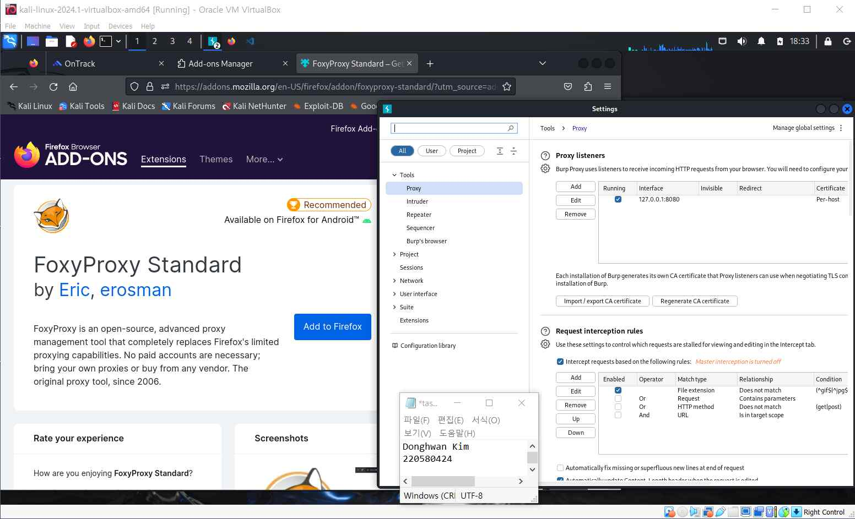
I added foxyproxy on firefox and matched the host name and port number of Buff
Suite to prepare to use Buff Suite.

Step 2.
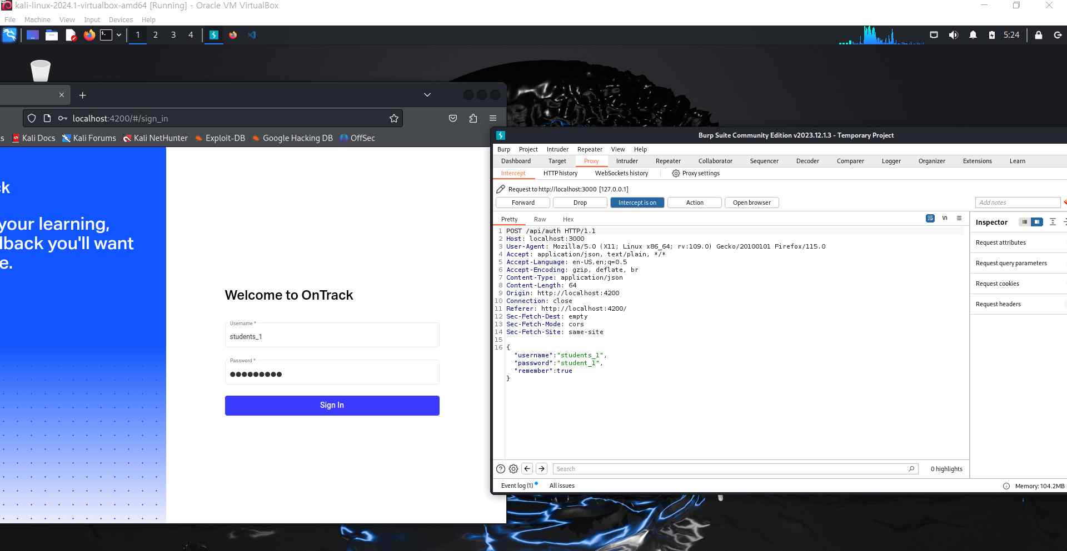
I turned on the intercept of the proxy in Buff Suite.
This is a concept that allows you to intercept the proxy of localhost:4200 in the
middle to know the operation status within Burp Suite.

Step 3.
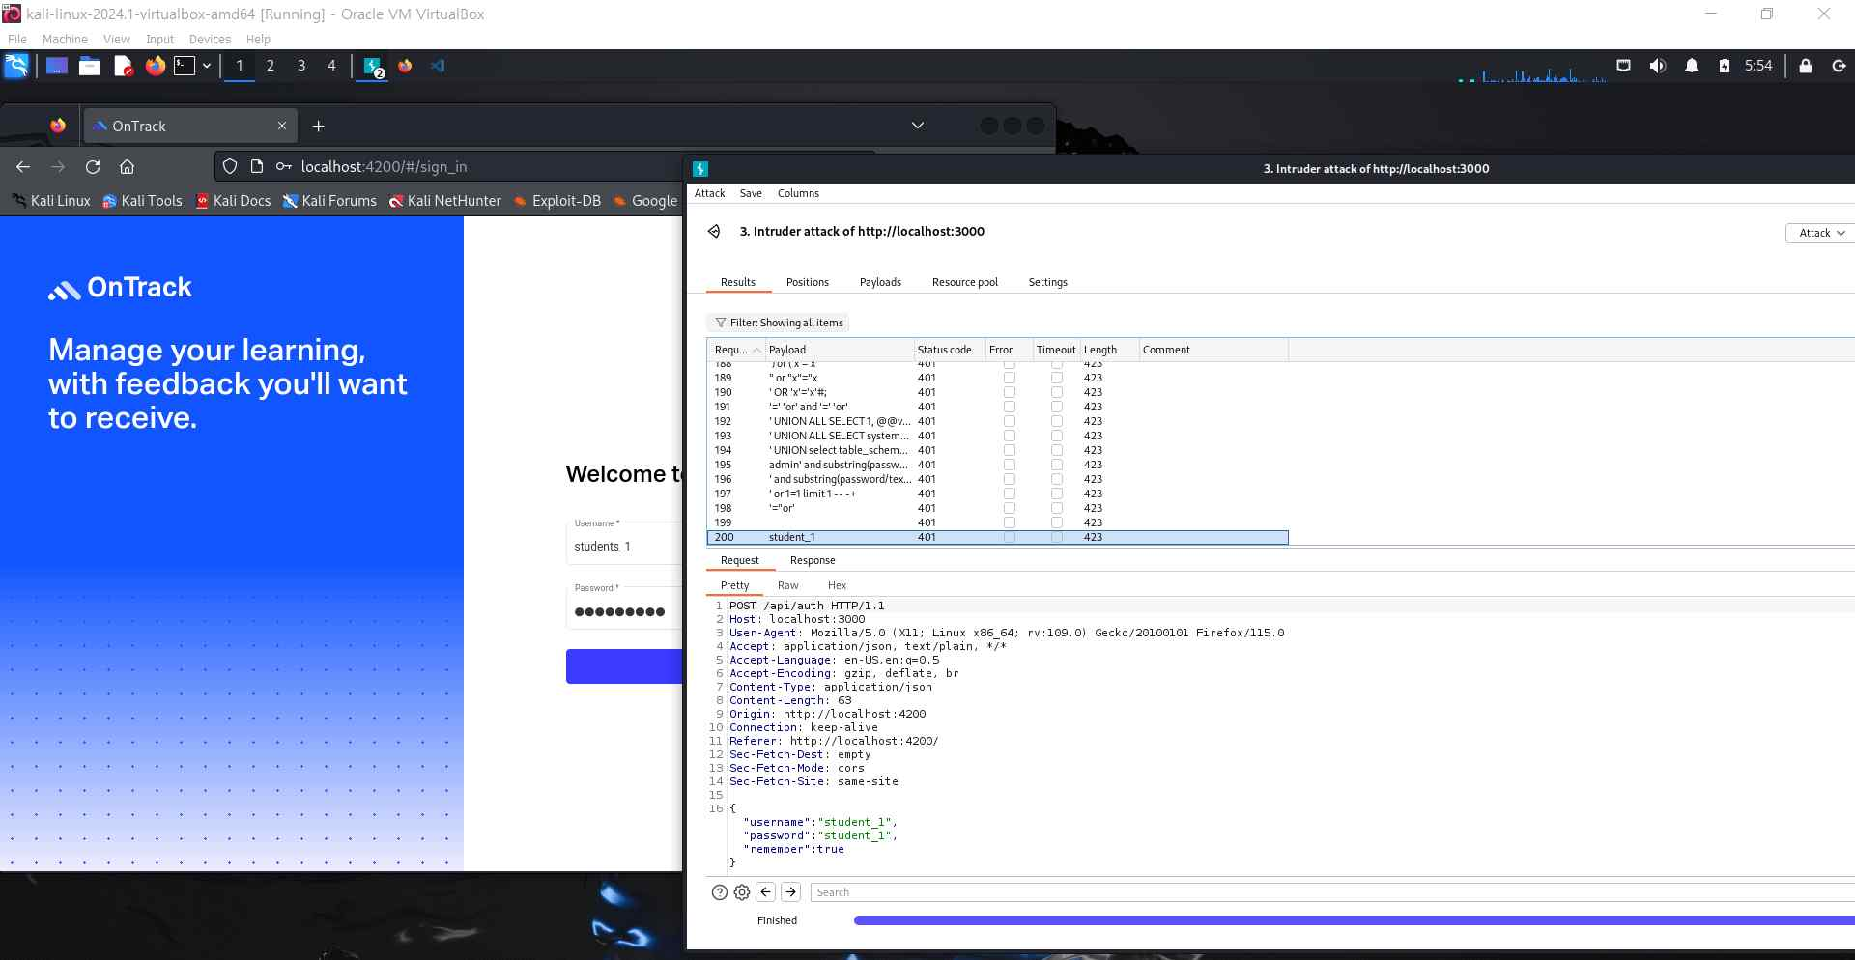
I ran a SQL Injection attack and was able to find the same ID as the current one.
That is, it was found that localhost:4200 has a vulnerability in SQL

Etc..

Remediation Advice
In order to resolve this vulnerability in SQL injection, it seems necessary to use a method of verifying and rescuing the values entered.
Escaping is the conversion of special characters that can be used in SQL queries to prevent malicious code from being executed.

References
https://portswigger.net/burp/documentation/desktop/testing-workflow/input-validation/sql-injection/testing
Testing for SQL injection vulnerabilities with Burp Suite
(March, 2024)

Testing for SQL injection vulnerabilities with Burp Suite
Contact Details
Donghwan Kim (220580424)
kimdongh@deakin.edu.au

Pentest Leader Feedback.
The lead will provide feedback to enact on.

